Asheeth Manu

asheethmanu@gmail.com

Abstract

[Draw your reader in with an engaging abstract. It is typically a short summary of the document.   
When you’re ready to add your content, just click here and start typing.]

PRI project

**Livreur - Delivery WebApp**

Table of Contents

Version Control 2

Background 3

How does *<app name>* work? 4

The Customer: 4

The Vendor: 4

The Deliverer: 5

# Version Control

|  |  |  |  |
| --- | --- | --- | --- |
| Version Number | Version changes | Modified by | Date |
| 1.0 | First draft | Asheeth Manu | 22/09/2017 |
| 2.0 | Added process flow for User login & registration processes | Asheeth Manu | 01/10/2017 |
|  |  |  |  |

# Background

Paris, like any other big city, is a busy city. People are rushing from one place to another, busy with work and family commitments. In an increasingly competitive world, work timings have expanded and personal time has shrunk. The cost for this is usually paid for by limited personal time, leading to stress.

With the shops and supermarkets only open during certain times and certain days, online purchasing has been gaining popularity. However, one is restricted to purchasing from only certain big retailers who do offer online ordering and delivery. Most shops and establishments, however, do not offer this facility.

While in the recent years, there has been a surge in delivery services for food from restaurants with apps like Deliveroo, Uber Eats etc. making food ordering and delivery very convenient, there’s not much available in terms of daily needs delivery or small ticket deliveries. Also, these usually come with a minimum order cost, which is not always suitable.

It is to fill this gap that we decided to launch <*App name>* as a solution for the customer’s needs.

# How does *<app name>* work?

The app basically has 3 players – The Customer, The Vendor and The Delivery man. Each player would have a customized UI, with dashboards for easy access.

## The Customer:

The Customer downloads the app on their smartphone (available on both Google Play and Apple Store) and puts in their credit card/ e-wallet (no cash).

The app allows the customer to –

1. Search for a shop/store to get contact details. The search can be based on name, product, geographical area, or app ranking.
2. Link to their online store (if the shop/store has one).
3. Place an order
   1. In case the shop/store does not have an online store, the customer would request the items they want.
   2. The vendor would then check their inventory for availability and confirm the order (or part thereof) with the price.
   3. The customer confirms the order and the payment is deducted from the customer’s credit card/ e-wallet.
   4. The payment is processed by our payment gateway, and the vendor is informed.
   5. The customer receives a confirmation of the order.
   6. The customer can then schedule a delivery of the order – either immediate (Phase 1) or later (Phase 2).
   7. The customer is shown the delivery persons available and their bids for the delivery.
   8. The customer chooses one and confirms.
   9. The delivery is then done at the date/time given by the customer.
   10. Once the delivery is done, both the customer and the deliverer confirm it on their respective apps.
   11. The payment to the deliverer is then deducted from the Customer’s credit card/ e-wallet.
   12. The transaction is saved in the order history for future reference.
   13. The customer is then asked to rank the vendor and the deliverer.
   14. If the customer is not satisfied with the delivered product or delivery, they can raise a complaint.

## The Vendor:

1. The vendor needs to be registered on the app.
2. At the time of registration, all vendor details will be verified – location, bank details etc.
3. The vendor can show their availability for ordering on the app by a simple toggle switch.
4. When the customer places an order on the app, the vendor has to confirm the availability and the price.
5. Once the order is confirmed by the customer, and paid for, the vendor gets an alert.
6. Once the deliverer is confirmed by the customer, the vendor get another alert with the date, time, and details of the collector (name, id number, mobile number etc.).
7. Once the delivery is completed, the order on vendor’s app is updated.
8. In case of any complaints, the vendor is notified, and the app works with the customer-vendor to resolve the issue.
9. The vendor rating/ feedback is available for the vendor to respond to.
10. Payment to vendor will be done every week/ every two weeks.

## The Deliverer:

There’s no specific requirement for a deliverer. Anyone with time to spare can be a deliverer.

1. The deliverer must register with the app with their details which would be verified.
2. The details required –
   1. First Name
   2. Family Name
   3. Address
   4. Identity proof
   5. Vehicle
   6. If yes, copy of –
      1. Vehicle registration
      2. Driving License
   7. RIB details
   8. Photograph
3. The deliverer can show availability by a toggle on the app.
4. When the customer puts out an offer for delivery, it must be bid for and confirmed within 5 minutes.
5. The bidding will be visible to all the deliverers and they would be allowed to make changes in those 5 minutes.
6. Once the bidding is confirmed, it cannot be changed.
7. Customer and vendor information will be shared with the deliverer.
8. Once the goods have been collected, the app must be updated.
9. Once the goods have been delivered, the app must be updated.
10. After delivery of the goods, the account balance of the deliverer will be updated.
11. Payment to the deliverer will be made once every week/ every 2 weeks.

# Process Flow Diagrams

## User Registration Process

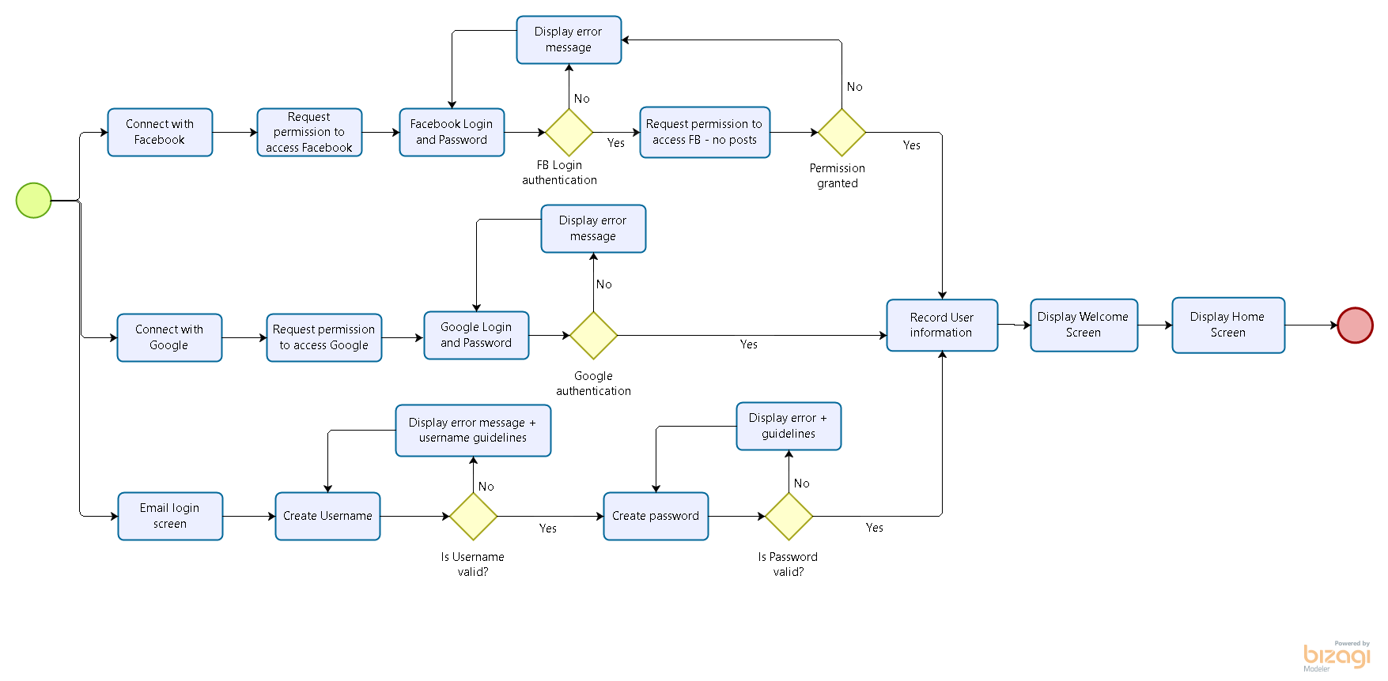

## User Login Process

